13. ACTIVITY

13. identify and correct any misconfiguration of a wireless device.

* **Types of Wireless Network Attacks: Misconfiguration**

#### There has been much talk concerning the flaws in software, along with the numerous system exploits being disclosed on a daily basis. However, security experts are more concerned that this serves as a distraction to IT professionals who should be focusing on a more severe problem - improperly secured wireless networks. Today's wireless environments are so poorly configured and managed that attackers can virtually walk right through without attracting too much attention.

* **The concern of mismatched software and hardware**

The problem arises from the plethora of mismatched software and hardware, making way for a network infrastructure that is vulnerable to a wide range of attacks. In some cases, the devices may function properly but are terribly misconfigured. While several companies take the first step by implementing a security system, many more fail to maintain them, causing these implementations to be inefficient.

* **Incorporating SSID**

SSID (Service Set ID) is a configurable identification mechanism that enables a client to communicate with the correct base station; all stations come included with their own default SSID. When configured properly, only clients configured with the corresponding SSID can interact with the base station. An attacker can exploit the default SSIDs in attempt to access a base station that may have still have its default configuration. Some will change the default SSID password to something simple, ultimately making the network just as vulnerable.

## ****Expert opinion****

Lisa Phifer, Vice President of Core Competence Inc., has been actively involved in the development, implementation and evaluation of internetworking security, communications and network management solutions for more than 20 years. She has advised companies from small to large in regard to product assessment, security needs and the overall importance of using the best practices of emerging technologies. In a recent interview, Lisa noted that the Code Red worm was amazingly still infecting network servers at the end of 2007. This is very unsettling considering the fact that virus signatures and server patches to contain the infection have been readily available since 2001. Like most experts, Phifer blames this continuous outbreak on misconfiguration. She went on to state that Gartner Research has predicted that misconfiguration will account for an estimated 70% of successful wireless LAN attacks through the year 2009.

## Diagnosing Home Network Misconfigurations using Shared Knowledge

### **The Problem**

NetPrints is a home-networking troubleshooting system that uses shared knowledge to diagnose and fix misconfigurations in the home network.

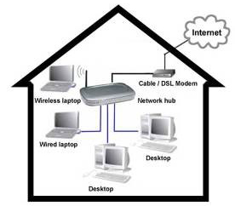

Today’s home network is typically a collection of several devices and applications. While the broadband modem acts as the home’s window to the Internet world, there are a variety of different hardware and software components that interact within people’s homes. For example, you may have a wireless router attached to your broadband modem, with several laptops and desktops connecting both through wires and wirelessly to the router. Additionally, you may have special-purpose devices such as gaming consoles or Wi-Fi media players connected as well. This creates an rich, diverse and unmanaged network in the home which, more often than not, has to be administered and configured by the home users themselves. Configuring the home network such that all applications and devices work as expected is extremely difficult. Evidence of this can be found on technical support websites, forums and mailing-lists that hold posts related to a countless number of problems such as:

“My Xbox does not connect to the Xbox Live service.”

 “My Xbox 360 doesn’t work with the wireless network.”

“My VPN client does not work from home.”

 “My browser takes ages to load any website.”

“I have set up an FTP server on my machine but it does not work.”

 “My IM client does not work from home.”

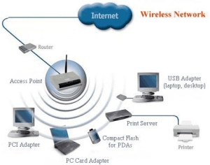

### **Advantages and Disadvantages of Wireless Communications**

### **Advantages:**

* Information can be transmitted quickly with high speed and accuracy.
* The internet can be accessed from anywhere, at any time without any cables or wires.
* Emergency situations can be alerted through wireless communication.
* Wireless, no bunches of wire running out.
* Communication can reach where wiring is not feasible and costly.

### **Disadvantages:**

* An Unauthorized person can easily misuse the wireless signals which spread through the air.
* It is very important to secure the wireless network to protect information.
* High cost to set up the infrastructure.
* Wireless communication is influenced by physical constructions, climatic conditions and interference from other wireless devices.